**5.8-2** Consider a system with impulse response $h\left[n\right]={\left(0.9\right)}^{n}u\left[n\right]+2{\left(-0.3\right)}^{n}u[n]$. Determine this system’s time constant, rise time, and pulse dispersion. Identify, if possible, an input *x*[*n*] that will cause this system to resonate.

**Time Constant)**

Here is h[n] plotted

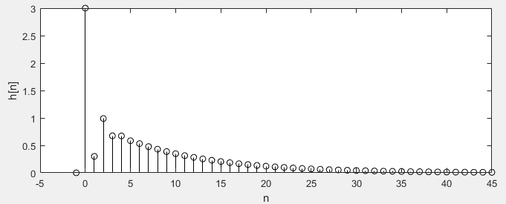

The n=0 value seems out of place… so I’m going to ignore it. I’m going to choose my $W_{h}$ at where the amplitude is 1% of the peak height of h[n] (still disregarding 3 at n=0). This will be where h[n] = ~0.01, or at n = 44

Then, the width is: $W_{h}=0→44=45$

**Rise Time)**

According to eq. 5.39 the rise time is just equal to the time constant



$$W_{r}=45$$

**Pulse Dispersion)**

According to the book, the pulse dispersion width is equal to the time constant as well

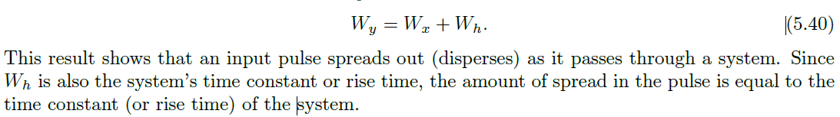

$$pulse dispersion=45$$

**An input x[n] that resonates with this system)**

From pg. 316 in the book:

If $h\left[n\right]={cγ}^{n}u\left[n\right] and x\left[n\right]={(γ-ϵ)}^{n}u\left[n\right]$

Then as $ϵ→0 y\left[n\right]=c\left(n+1\right)γ^{n}u[n]$

If we have an input $x\left[n\right]$ such that $x\left[n\right]=x_{1}\left[n\right]+x_{2}[n]$. Where,

$$x_{1}\left[n\right]={0.9}^{n}u\left[n\right] and x_{2}\left[n\right]={\left(-0.3\right)}^{n}u\left[n\right]$$

Then, our $y\left[n\right]=y_{1}\left[n\right]+y_{2}\left[n\right]=h\left[n\right]*x_{1}\left[n\right]+\left[n\right]*x_{2}[n]$

$$y_{1}\left[n\right]=\left(n+1\right){\left(0.9\right)}^{n}u\left[n\right]+2\frac{{\left(-0.3\right)}^{n+1}-{\left(0.9\right)}^{n+1}}{-1.2}u[n]$$

$$y_{2}\left[n\right]=2\left(n+1\right){\left(-0.3\right)}^{n}u\left[n\right]+\frac{{\left(-0.3\right)}^{n+1}-{\left(0.9\right)}^{n+1}}{-1.2}u[n]$$

$$y\left[n\right]=\left(n+1\right){\left(0.9\right)}^{n}u\left[n\right]+2\left(n+1\right){\left(-0.3\right)}^{n}u\left[n\right]+3\frac{{\left(-0.3\right)}^{n+1}-{\left(0.9\right)}^{n+1}}{-1.2}u[n]$$

Or in MATLAB,

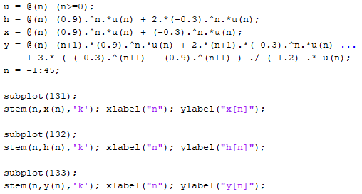

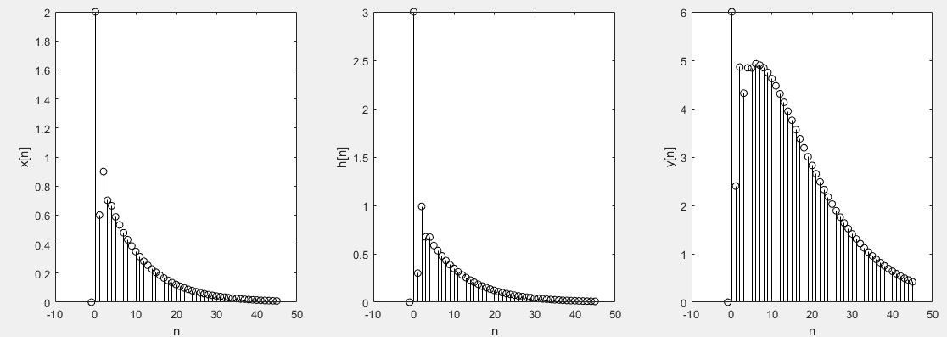

It goes to zero, but in our y[n] we can see that there the (n+1) term will go to infinity as n goes to infinity. This output will decay before that can go to infinity since its roots are within the unit circle, but it still resonates with the system.